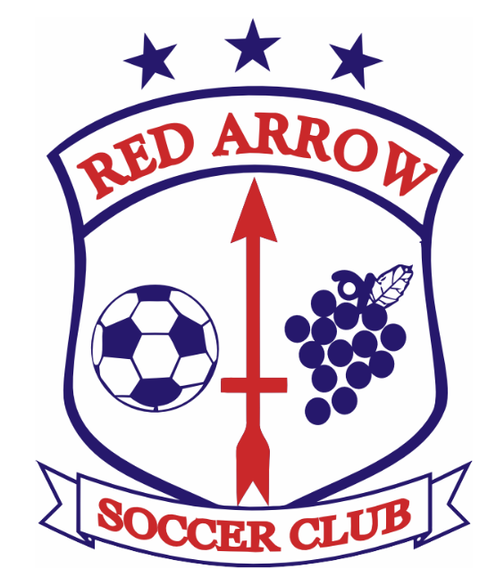

Red Arrow Junior Academy

Structure Programs Offered
Minis Academy U5-U6 Full Year
2019-2018 Birth Years Fall Only
Juniors Academy U7-U8 Winter Only
2017-2016 Birth Years Spring Only
Summer Camp

Locations
Fall and Spring
Primary Outdoor location at Paw Paw Middle School
313 W. Michigan Ave., Paw Paw, MI 49079
South End of field nearest baseball fields
Winter
Official Winter 2023-2024 location to be determined

Training Day Needs - Please come prepared
- Soccer Shoes-Cleats preferred
- Shinguards for Minis and Juniors ages
- Soccer ball-
Minis - Size 3
Juniors - Size 3 or 4

Training Dates/Times

RASC Minis Academy
Day | Time | Fall Dates | Winter Dates | Spring Dates
Wednesday | 5:30-6:30pm | Aug 30  Sept 6, 13, 20, 27  Oct 4, 11, 18 | Tentative  Jan 10, 17, 24, 31  Feb 7, 14, 21, 28  Mar 6, 13 | Tentative  Apr 17, 24  May 1, 8, 15, 22, 29  June 5

RASC Juniors Academy
Day | Time | Fall Dates | Winter Dates | Spring Dates
Wednesday | 6:30-7:30pm | Aug 30  Sep 6,13, 20, 29  Oct 6,11,18 | Tentative  Jan 10, 17, 24, 31  Feb 7, 14, 21, 28  Mar 6, 13 | Tentative  Apr 17, 24  May 1, 8, 15, 22, 29  June 5
Sunday | 11-12pm | Sep 17, 24  Oct 1, 8, 15, 22 |  | Tentative  Apr 21, 28  May 5, 12, 19  June 5

Uniforms
All uniforms will be handed out in the second week of training. All Minis and Juniors will receive a shirt for game play.

Other
- Volunteer coaches are still needed. Let us know if you or someone you know may be interested.
- We are always looking to add more kids to the program. If you know someone, have them contact us.
- Check the website if you have questions. There are more details there.
  - www.redarrowsoccer.com
- Like us on Facebook: https://www.facebook.com/RedArrowSoccer
Other questions, contact
- Juniors Academy Director Mike Mansfield mmansfield@redarrowsoccer.com
- Coaching and Technical Director Chris Stamatopoulos
doc@redarrowsoccer.com
- Registrar Kristy Lounsbury
registrar@redarrowsoccer.com
- Red Arrow Club President Matt Haring
president@redarrowsoccer.com

